Proyecto Redes

Contenido

Tabla de direcciones 2

Topología 3

Comandos 3

Router 1 3

VLAN 3

DHCP 4

OSPF 4

Router 2 (Border router) 4

OSPF 5

NAT 5

Syslog 6

Router 3 6

OSPF 6

DHCP 6

Router ISP 6

S1 7

VLAN 7

Interfaces 7

S2 7

VLAN 8

Interfaces 8

PORT SECURITY 8

ACL’s 9

Configuración Wireless Router 10

Descripción 10

Requerimientos 10

Configuración router 10

Configuración Servidor FreeRadius 10

# Tabla de direcciones

|  |  |  |  |  |
| --- | --- | --- | --- | --- |
| **Dispositivo** | **Interfaz** | **IP Address** | **Subnet** | **Default Gatway** |
| **R1** | Gig0/0.11 | 192.168.11.1 | 255.255.255.0 |  |
| Gig0/0.12 | 192.168.12.1 | 255.255.255.0 |  |
| Gig0/0.12 | 192.168.99.1 | 255.255.255.0 |  |
| Se0/0/0 | 10.10.1.1 | 255.255.255.252 |  |
| **S1** | VLAN99 | -- | -- | 192.168.99.1 |
| **PC5** | Fa0/4 | DHCP VLAN12 | 255.255.255.0 | 192.168.12.1 |
| **S2** | VLAN99 | -- | -- | 192.168.99.1 |
| **PC6** | Fa0/1 | DHCP VLAN11 | 255.255.255.0 | 192.168.11.1 |
| **R2 (Border router)** | Se0/0/0 | 10.10.1.2 | 255.255.255.252 |  |
| Se0/0/1 | 10.10.2.1 | 255.255.255.252 |  |
| G0/0 | 200.10.1.1 | 255.255.255.0 |  |
| **ISP** | G0/1 | 200.10.1.2 | 255.255.255.0 |  |
| G0/0 | 200.10.1.1 | 255.255.255.0 |  |
| **PC1** | Fa0 | 200.20.1.2 | 255.255.255.0 | 200.20.1.1 |
| **R3** | Se0/0/1 | 10.10.2.1 | 255.255.255.252 |  |
| Gig0/1 | 192.168.5.1 | 255.255.255.0 |  |
| Gig0/0 | 192.168.4.1 | 255.255.255.0 |  |
| **Syslog** | Gig0/0 | 192.168.4.2 | 255.255.255.0 | 192.168.4.1 |
| **Wireless Router 0** | Gig0/1 | 192.168.5.1 | 255.255.255.0 | 192.168.5.1 |

# Topología

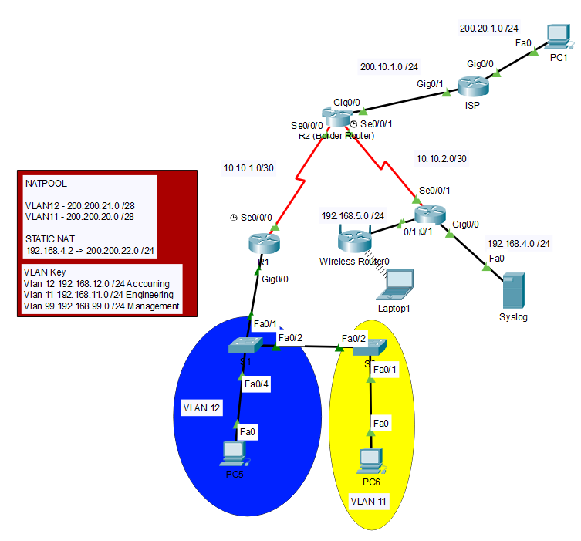

# Comandos

## Router 1

Router(config)#hostname R1

R1(config)#interface s0/0/0

R1(config-if)#ip address 10.10.1.1 255.255.255.252

R1(config-if)#no shu

R1(config-if)#clock rate 4000000

*-----------------------------*

### VLAN

R1(config)#interface g0/0.12

R1(config-subif)#encapsulation dot1Q 12

R1(config-subif)#ip address 192.168.12.1 255.255.255.0

R1(config)#interface g0/0.11

R1(config-subif)#encapsulation dot1Q 11

R1(config-subif)#ip address 192.168.11.1 255.255.255.0

R1(config)#interface g0/0.99

R1(config-subif)#encapsulation dot1Q 99

R1(config-subif)#ip address 192.168.99.1 255.255.255.0

R1(config-subif)exit

R1(config)#interface g0/0

R1(config-if)#no shutdown

*------------------------------*

### DHCP

R1(config)#ip dhcp excluded-address 192.168.12.1 192.168.12.20

R1(config)#ip dhcp excluded-address 192.168.11.1 192.168.11.20

R1(config)#ip dhcp excluded-address 192.168.99.1 192.168.99.20

R1(dhcp-config)#ip dhcp pool VLAN11

R1(dhcp-config)#dns-server 8.8.8.8

R1(dhcp-config)#domain-name cisco.com

R1(dhcp-config)#network 192.168.11.0 255.255.255.0

R1(config)#ip dhcp pool VLAN12

R1(dhcp-config)#dns

R1(dhcp-config)#dns-server 8.8.8.8

R1(dhcp-config)#domain-name cisco.com

R1(dhcp-config)#net

R1(dhcp-config)#network 192.168.12.0 255.255.255.0

R1(dhcp-config)#default-router 192.168.12.1

*------------------------------*

### OSPF

R1(config)#router ospf 10

R1(config-router)#router-id 1.1.1.1

R1(config-router)#passive-interface g0/0

R1(config-router)#network 192.168.12.0 0.0.0.255 area 0

R1(config-router)#network 10.10.1.0 0.0.0.3 area 0

R1(config-router)#network 192.168.11.0 0.0.0.255 area 0

R1(config-router)#network 192.168.99.0 0.0.0.255 area 0

## Router 2 (Border router)

R2(config)#interface s0/0/0

R2(config-if)#ip ad

R2(config-if)#ip address 10.10.1.2 255.255.255.252

R2(config-if)#no shutdown

Router(config)#hostname R2

Router(config)#interface g0/0

Router(config-if)#ip address 200.10.1.1 255.255.255.0

R2(config-if)#no shutdown

R2(config-if)#interface s0/0/1

R2(config-if)#ip address 10.10.2.1 255.255.255.252

R2(config-if)#no shutdown

R2(config-if)#clock rate 4000000

*-------------------------------*

### OSPF

R2(config)#route ospf 10

R2(config-router)#router-id 2.2.2.2

R2(config-router)#network 10.10.1.0 0.0.0.3 area 0

R2(config-router)#network 10.10.2.0 0.0.0.3 area 0

R2(config-router)#default-information originate

*-------------------------------*

### NAT

R2(config)#interface g0/0

R2(config-if)#ip nat outside

BD(config)#interface s0/0/1

BD(config-if)#ip nat inside

R2(config-if)#interface s0/0/0

R2(config-if)#ip nat inside

BD(config)#ip nat inside source static 192.168.4.2 200.200.22.1

BD(config)#ip route 0.0.0.0 0.0.0.0 g0/0

BD(config)#access-list 11 permit 192.168.11.0 0.0.0.255

BD(config)#access-list 12 permit 192.168.12.0 0.0.0.255

BD(config)#ip nat pool VLAN11 200.200.20.1 200.200.20.15 netmask 255.255.255.240

BD(config)#ip nat pool VLAN12 200.200.21.1 200.200.21.15 netmask 255.255.255.240

BD(config)#ip nat inside source list 11 pool VLAN11

BD(config)#ip nat inside source list 12 pool VLAN12

*-------------------------------*

### Syslog

BD(config)#loggin host 192.168.4.2

BD(config)#service timestamps log datetime msec

BD(config)#username admin secret 1234

## Router 3

Router(config)#hostname R3

R3(config)#INT

R3(config)#INTerface s0/0/1

R3(config-if)#IP ADdress 10.10.2.2 255.255.255.252

R3(config-if)#NO SHUT

R3(config)#interface g0/0

R3(config-if)#ip address 192.168.4.1 255.255.255.0

R3(config-if)#no shutdown

*-------------------------------*

### OSPF

R3(config)#router ospf 10

R3(config-router)#router-id 3.3.3.3

R3(config-router)#passive-interface g0/0

R3(config-router)#network 10.10.2.0 0.0.0.3 area 0

R3(config-router)#network 192.168.4.0 0.0.0.255 area 0

R3(config)#interface g0/1

R3(config-if)#ip address 192.168.5.1 255.255.255.0

*---------------------------------*

### DHCP

R3(config)#ip dhcp excluded-address 192.168.5.1 192.168.5.20

R3(config)#ip dhcp pool WIRELESS

R3(dhcp-config)#NETwork 192.168.5.0 255.255.255.0

R3(dhcp-config)#default-router 192.168.5.1

## Router ISP

Router(config)#hostname ISP

ISP(config)#interface Gig0/0

ISP(config-if)#ip address 200.20.1.1 255.255.255.0

ISP(config-if)#no shutdown

ISP(config)#interface Gig0/1

ISP(config-if)#ip address 200.10.1.2 255.255.255.0

ISP(config-if)#no shutdown

ISP(config)#ip route 200.200.20.0 255.255.252.0 g0/1

## S1

*---------------------------------*

### VLAN

S1(config)#interface vlan 99

S1(config-if)#ip address 192.168.99.2 255.255.255.0

VLAN 12

name vlan Accouning

VLAN 11

name vlan Engineering

VLAN 99

S1(config)#ip default-gateway 192.168.99.1

name vlan Engineering

*---------------------------------*

## Interfaces

S1(config)#interface f0/2

S1(config-if)#switchport mode trunk

S1(config)#INTERface f0/1

S1(config-if)#switchport mode trunk

S1(config)#interface fa0/3

S1(config-if)#switchport mode access

S1(config-if)#switchport access vlan 12

S1(config)#interface fa0/4

S1(config-if)#switchport mode access

S1(config-if)#switchport access vlan 12

## S2

*---------------------------------*

### VLAN

S2(config)#interface vlan 99

S2(config-if)#ip address 192.168.99.3 255.255.255.0

VLAN 12

name vlan Accouning

VLAN 11

name vlan Engineering

VLAN 99

name vlan Engineering

S2(config)#ip default-gateway 192.168.99.1

*---------------------------------*

## Interfaces

S2(config)#interface fa0/2

S2(config-if)#switchport mode trunk

Switch(config-if)#interface f0/1

witch(config-if)#switchport mode access

Switch(config-if)#switchport access vlan 11

# PORT SECURITY

int fa0/1

S2(config-if)#switchport port-security mac-address sticky

S2(config-if)#switchport port-security maximum 5

int fa0/4

port security

int fa0/1

S2(config-if)#switchport port-security mac-address sticky

S2(config-if)#switchport port-security maximum 5

# ACL’s

ACL config

BD(config)#access-list 101 remark outbound traffic

BD(config)#access-list 101 permit tcp 10.10.2.0 0.0.0.3 any eq 80

BD(config)#access-list 101 permit tcp 10.10.2.0 0.0.0.3 any eq 443

BD(config)#access-list 102 remark inbound traffic

BD(config)#access-list 102 permit tcp any 10.10.2.0 0.0.0.3

*---------------------------------*

Securing VTY ports

R1(config)#line vty 0 4

R1(config-line)#login local

R1(config-line)#transport input ssh

R1(config-line)#access-class 21 in

R1(config-line)#exit

R1(config)#access-list 21 permit 192.168.99.0 0.0.0.255

R1(config)#access-list 21 deny any

*-------------------------------*

Navegación

R1(config)#ip access-list extended SURFING

R1(config-ext-nacl)#permit tcp 192.168.12.0 0.0.0.255 any eq 80

R1(config-ext-nacl)#permit tcp 192.168.12.0 0.0.0.255 any eq 443

R1(config)#ip access-list extended BROWSING

R1(config-ext-nacl)#permit tcp any 192.168.12.0 0.0.0.255 established

R1(config)#interface g0/0

R1(config-if)#ip access-group SURFING in

R1(config-if)#ip access-group BROWSING out

*---------------------------------*

R3(config)#ip access-list standard ONLYACCESSVLAN11

R3(config-std-nacl)#PERMit 192.168.11.0 0.0.0.255

R3(config)#interface g0/0

R3(config-if)#ip access-group ONLYACCESSVLAN11 out

# Configuración Wireless Router

## Descripción

Para poder utilizar el Wireless Router utilizamos un servidor Radius el cual consiste en un protocolo de autorización para poder acceder a nuestra red.

## Requerimientos

* Wireless Router (Linksys E5800 en este caso)
* Computadora con sistema operativo Windows 8+
* Servidor FreeRadius instalado en la computadora mencionada

## Configuración router

* Reiniciar el router.
* Conectar al pc para realizar la configuración.
* Asignar una red estática al pc.
* Abrir un navegador e ingresar la dirección 192.168.1.1.

## Configuración Servidor FreeRadius

* Instalar servidor freeradius
* Configurar -> Clients.conf
* Configurar -> Users
* Configurar -> testuser

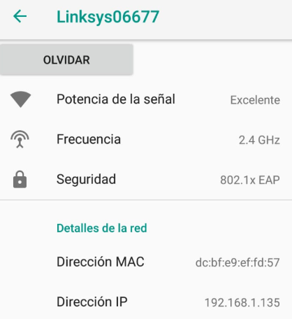

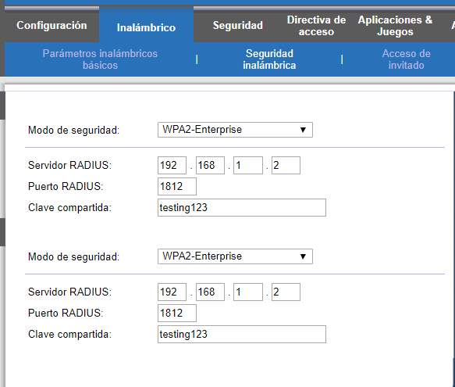

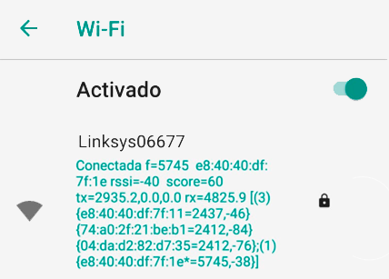

En la sección de inalámbrico después de acceder a la dirección 192.168.1.1 Usamos WPA-2-Enterprise como se ve en la imagen

Se configura clients de la siguiente manera:

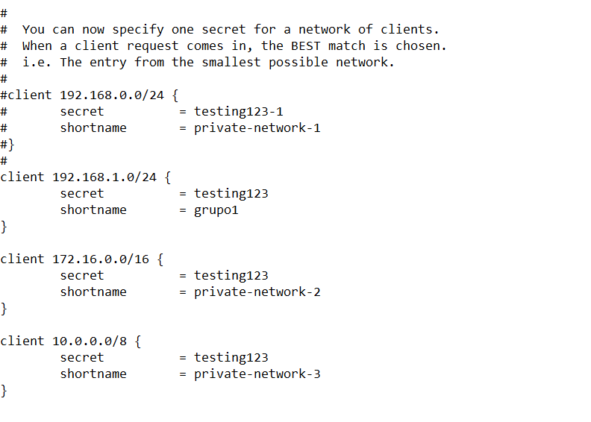

Se configura user de la siguiente forma:



Se inicializa el FreeRadius

